**Mathematics in GNU Octave**

**CONTENTS**

**I.** **ELEMENTARY OPERATIONS**

* Addition, Subtraction, Multiplication, and Division
* Squares and Square Roots

**II. MATRICES**

* Creating Matrices
* Matrix Operations

**III. DATA CONTAINERS**

* Cell Arrays

**IV. FUNCTION PLOTTING**

* Two-Dimensional Function Plotting
* Three-Dimensional Function Plotting

**V. ARITHMETIC**

* Exponents and Logarithms
* Floor and Ceiling Functions
* Rounding
* Factorials
* Maximum and Minimum
* Modulo
* Least Common Multiple and Greatest Common Divisor

**VI. DIFFERENTIAL EQUATIONS**

* Derivatives
* Integrals

**VII. LINEAR ALGEBRA**

* Determinants
* Inverse
* Eigenvalues
* Dot and Cross Products
* Solving Linear Systems

**VIII. STATISTICS**

* Mean, Median, and Mode
* Standard Deviation and Variance
* Set Operations

**A. USING COMMAND LINE / TERMINAL AND IDE**

Octave can be used through either the command line or terminal or its integrated development environment. All of the examples below are completed using the terminal.

**I. ELEMENTARY OPERATIONS**

**Addition, Subtraction, Multiplication, and Division**

**Squares and Square Roots**

**II. MATRICES**

**Creating Matrices**

Each column is divided by a semicolon. This is a 3 x 3 matrix.

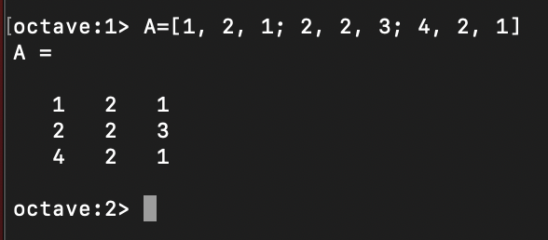

**Matrix Operations**

Matrix multiplication is shown below. A*B does not work since the number of columns of A does not equal the number of rows of B.

A’ is the transpose of A, the interchanging of rows and columns.

**III. DATA CONTAINERS**

**Cell Arrays**

A cell array can store several variables of different size or type in one variable.

**IV. FUNCTION PLOTTING**

**Two-Dimensional Function Plotting**

**Three-Dimensional Function Plotting**

To graph with contour lines, change “mesh” to “meshc”.

**V. ARITHMETIC**

**Exponents and Logarithms**

**Floor and Ceiling Functions**

**Rounding**

**Factorials**

**Maximum and Minimum**

**Modulo**

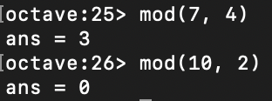

**Least Common Multiple and Greatest Common Divisor**

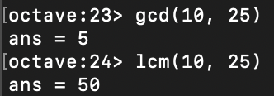

**VI. DIFFERENTIAL EQUATIONS**

**Derivatives**

By downloading the “optim” package and ensuring to run it every time it gets used, derivatives can be calculated using the form:

**Integrals**

**VII. LINEAR ALGEBRA**

**Determinants**

**Inverse**

**Eigenvalues**

**Dot and Cross Products**

**Solving Linear Systems**

In addition to the Linear Algebra examples above, other topics such as rank, dimension, and null spaces can also be calculated.

**VIII. STATISTICS**

**Mean, Median, and Mode**

**Standard Deviation and Variance**

**Set Operations**

There are also functions to calculate probability density functions and cumulative distribution functions.